Modified DACUM Research Chart  Machining  CIP #48.0501  DACUM Panel  Representing 164 years of experience in Machining  Abraham Bigelow, Training Manager  Ellwood National Forge, Irvine, PA  Steve Crowther, Tool Room Supervisor  Tonnard Manufacturing, Corry, PA  Wilma Dunkle, Business Manager  MPE Machine Tool, Inc., Corry, PA  Jeff Horneman, Operations Manager  Port Erie Plastics, Harborcreek, Pa  Rob Suprynowicz, Precision Machining Teacher  Erie County Technical School, Erie, PA  Wesley McCray, Design Engineer  Corry Manufacturing Company, Corry, PA  Observers and Facilitator  Cody Willis, Machining Instructor  Corry Area High School Career & Technical Education Center, Corry, PA  Susan Bogert, Supervisor of Vocational Education  Corry Area High School Career & Technical Education Center, Corry, PA  Jan Kennerknecht, DACUM Facilitator  Kennerknecht Consulting, Edinboro, PA  Mike Daniels, Cooperative Education Coordinator  Corry Area High School Career & Technical Education Center, Corry, PA |  | 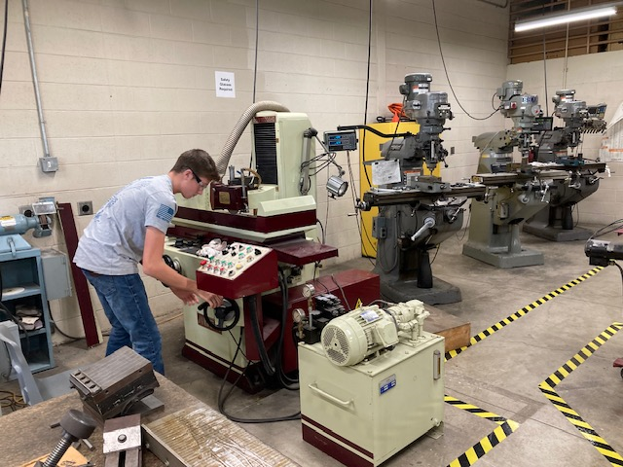  Sponsored by  Corry Area School District  Career & Technical Education Center  Produced by  October 6, 2023

General Knowledge

#1 is safety practices
Metallurgy
Knowledge of machining materials
Direction in life, what you want to be
Hand tools
Basic machines
Measuring instruments
Work ethics and company expectations
Company focus
Blueprints
First impressions
Basic tooling skills
Inspection reports, how to inspect work
Machine set-up
Machine upkeep (e.g., lubrication, cleaning)
Machining nomenclature
Documentation requirements
Machining formulas

General Skills

Troubleshooting skills
Organizational skills
Verbal communication skills
Written communication skills
Interpersonal skills (e.g., w/customers and co-workers)
Fundamental math skills (e.g., geometry, trigonometry)
Team building skills
Basic computer skills (e.g., Microsoft Office, Internet)

Worker Behaviors

Excellent attendance
Has good transportation
Team player
On time and ready for work!
Good attitude/willingness/respectful
On task, puts cell phone away during work hours
Considers the big picture is relevant to current task
Can receive constructive criticism
Learns from mistakes or failures
Desire to advance knowledge (drive to grow, continuous improvement)
Follows company rules
Self-motivated
Self-supervised
Can own mistakes and take responsibility

Current Trends

Greater need for employees and retention of employees is a concern.
Greater need to train new employees
Higher demand for automation (adding robotic arms to load/unload, robots for measuring dimensions on parts)
Cameras for inspection/production, used on G25 robots
Investment in robotics grew out of COVID impact
Employee behaviors have changed after COVID- lack of responsibility/ownership/tenacity for work.
Lack of concern for work, lack of discipline and respect
Focus and dedication is important and will reap rewards.
Background knowledge in maintenance and repairs is lacking. Greater need for training on this.
The manufacturing environment has become faster paced. Customers want things sooner. Causes a chain reaction, compounds the situation for need of training.
Supply chain issues are still a problem, but raw materials supply is better.
Different generations have different needs/wishes. Today’s new employees want to know the “why” regarding tasks, requests, rules, etc.
Schedule flexibility is based on production demands. May be able to work four ten-hour days based on production demands. Three-day weekends plus overtime can occur with four twelve-hour days.

Future Directions

AI will supplement skilled labor at some point.
Tool & Die makers will need to be knowledgeable about AI.
There will be a need for AI Operator or Co-programmer position.

Concerns

There is a concern for lack of skilled labor (engineers, toolmakers). Manufacturing could be affected in a big way.
Importing parts and molds from China, Mexico, India affects US businesses negatively.
There is a concern for numbers of motivated trainees, workers, people who want to learn.

Certifications Recommended

NIMS certifications are respected, but not required. May give applicant an edge in interview.
Mandated safety training (lock out/tag out, fork truck operations, OSHA training, PPE)
Voluntary First Aid training

General Recommendations for the Program

Consider rewarding students for good worker behaviors (e.g., can earn time for personal projects, T-shirt, certificate, notes of appreciation, post cards are easy)
Train them to be leaders (e.g., peer tutor, tool room attendant, assisting other students, tour guides)
Put together a “wish list” to share with local businesses for donations of supplies, steel, bronze, scrap metal, tools. Panel members mentioned several times that they want Corry’s Machining program to be successful.
Discuss injection molds with students. Ask industry member for a sample.
Consider “toggling” the afternoon curriculum content in alternating years.
Space is quite limited in the lab, consider removing the one bench type turret style collet lathe not being used. It is very limited on what it can produce (has very limited adjustability or part variance).

Advice for Students from DACUM Panel Members

Abe Bigelow – “Think through the process. Know what you want to accomplish before you start cutting.”
Steve Crowther – “Take ownership and pride in what you do. Never stop learning. If you make something, ask questions. Own it.”
Wilma Dunkle – “Never stop learning. Employees who are looking to learn are the ones who will be more successful.”
Jeff Horneman - “It is a rewarding career and can pay benefits, hard work is rewarding.”
Wes McCray – “When you make a mistake, it’s not a failure but an opportunity to learn.”
Rob Suprynowicz – “Focus, put blinders on from outside influences and media. Focus.”
Cody Willis - “If you fail to plan, you plan to fail. Execute your plan, become successful.”

Acronyms

AI Artificial Intelligence
GD&T Geometric Dimensioning and Tolerance
OSHA Occupational Safety and Health Administration
NIMS National Institute of Metalworking Skills
PM Preventive Maintenance
SPC Statistical Process Control

Program-Related Job Opportunities for Students

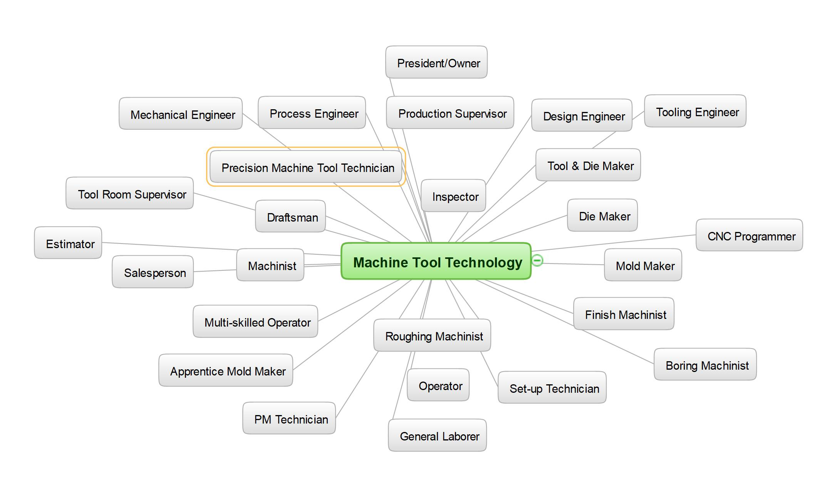

These are just some of the opportunities for graduates of the Machining program!

See attached Pennsylvania Machining Competency Task List for additional local tasks added by the DACUM panel. The Corry Area School District Career & Technical Education Center would like to thank this dedicated panel of professionals for providing their expertise. Corry CTEC will analyze this input for program improvement.

